Two “Lovebirds” Killed By Lightning Buried in One Grave (Malawi)
Written by Winstone Kaimira
Wednesday, 17 January 2018 16:26
https://zodiakmalawi.com/top-stories/two-lovebirds-killed-by-lightning-buried-in-one-grave
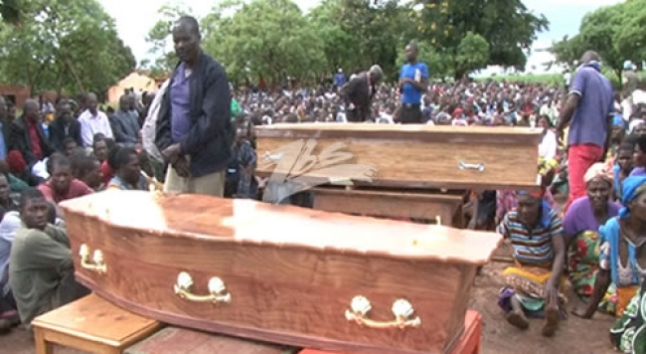The two died after being struck by lightning Monday evening in Lilongwe. Pic by Enoch Phiri
Thousands of people on Wednesday witnessed two bodies of two Standard 6 learners at Dzenza Primary School lowered in one grave at Mzondo Village in the area of traditional Authority Chitukula in Lilongwe.
The two died after being struck by lightning Monday evening in Lilongwe.
The two, 12 year old Patricia Guwe and Anderson Yohane aged 16, were reportedly in a love affair and they met their fate as they were chatting in a maize garden, meters away from their homes in the Village.
Some villagers discovered dead bodies of the two teenagers in the maize garden Tuesday morning.
The Church of Christ led the sorrowful event with prayers and songs.
In his eulogy, Village Head Njuzi of the area asked people to restrain from judging the two, saying the tragic incident could happen to anyone.
Zodiak Online was told that arrangement was normal in the area and is used whenever they need to burry two bodies upon approval of family members.
On his part a representative of Village head Chimombo said the death of Underson has created a gap in his chieftaincy as the boy was a future king.
A medical examination conducted at Kamuzu Central Hospital on Tuesday confirmed that the two died after being struck by lightning.
Last modified on Wednesday, 17 January 2018 16:53

