Lugari school appeals for arrestors after lightning strike [Kenya]

5th October 2023

https://www.kenyanews.go.ke/lugari-school-appeals-for-arrestors-after-lightning-strike/
Teachers and pupils of St. Paul’s Lugari Primary School in Lugari Sub County have appealed to the national and county governments to install lightning arrestors in the school to protect them from lightning strikes. The appeal follows two lightning strikes involving a teacher and a pupil in a span of one month. The school’s deputy head teacher, Tom Onjoche, said the two incidents, although not fatal, have forced teachers and pupils to be worried every time it is about to rain.

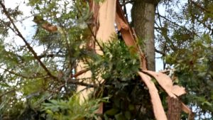
A tree struck by lightning recently at St. Paul’s Lugari primary school in Lugari Sub County. Photo by Melechezedeck Ejakait

Incident One
“The first incident, which occurred in early September, involved a teacher.
Incident Two
The second one, which happened a few days ago, affected one of our female pupils. We are now worried it might strike again, and the consequences might be worse,” Onjoche stated.
-----
The school’s senior teacher, Boniface Muyuka, echoed the deputy’s sentiments, saying the school needs lightning arrestors as soon as possible to avoid future tragedies. He recounted, “I have witnessed both incidents. The first occurred, and one of our teachers got injured, and he is still admitted to an Eldoret hospital. In the latest incident, lightning struck a tree within the school compound and injured a pupil. “The school is at risk. Everybody, including the teachers and the learners, is worried. We are appealing to both levels of government and the area members of parliament to come to our rescue. Once the arrestors are installed, we shall have solved the problem.” Muyuka said if the arrestors are not installed in the school, they will be forced to end classes whenever it is about to rain to guard themselves and the learners from unforeseen tragedies.

