Lubero: 4 dead in a rain in Miriki - DRC
Posted on Mon, 18/10/2021 - 15:36 | Modified on Mon, 18/10/2021 - 15:38
https://www.radiookapi.net/2021/10/18/actualite/societe/lubero-4-morts-lors-dune-pluie-miriki
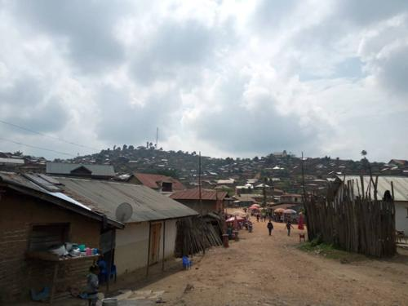
A view of the city of Kanyabayonga in Lubero territory. Photo Radio Okapi Marc Maro Fimbo
Four people died and others were injured in a heavy rain that fell on Saturday, October 16 in Miriki, in the chiefdom of Batangi, located in the south of Lubero.
According to the head of the Batangi chiefdom, Mwami Stuka Mwanaweka, the wounded are being taken care of in a medical structure in the region.
For his part, a civil society actor in the region, Amani Kinda puts forward a toll of six people killed by lightning, three in Miriki, two in Mihobwe and another who succumbed to her injuries near Kayina.
He also speaks of 4 other people injured by the same cataclysm.
Apart from this human damage, Amani Kinda claims that two houses were hit by fire and more than ten goats died from the same lightning in Miriki. More than five hectares of fields were also flooded in Kataro and a parish's electrical equipment damaged in Kayina. Amani Kinda
This heavy rain accompanied by violent wind which fell in this region affected several entities of the Batangi chiefdom.

