**Lightning strike claims two young lives in Mwiguriro Village - Uganda**

Reported and translated from a local story by Milton Kwesiga, Citizen Reporter - Uganda

28. April. 2024

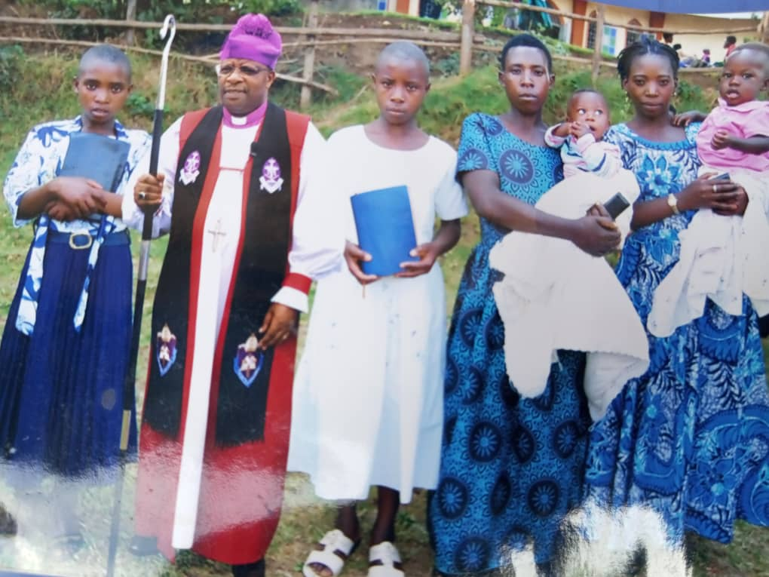

13-Year-old Kamukama Miracle (Standing next to Bishop holding a bible) pose for a family photo after her confirmation ceremony

A devastating lightning strike has claimed the lives of two children in Mwiguriro Village, leaving the community in shock and grief. The incident occurred at around 6:00 PM on Sunday, in Kakole Parish, Hamurwa Sub-county, Rubanda District, when a solar system installed at the family's home was struck by lightning, destroying the battery and killing the two children who were cooking in the wooden kitchen.

The victims, Kamukama Miracle (13) and Nabasa Johnson (9), were siblings who were alone at home while their parents, Musinguzi Gad (40) and Ninsiima Anna (35), were away at a trading center. Their sibling, who had been out grazing, discovered the tragic scene and alerted neighbors, who then notified the parents.

This tragic incident is the latest in a series of lightning strikes to affect the parish, which has been plagued by lightning-related incidents in recent years. According to the Chairman of the Local Council, Mr. Ndyeije Francis, lightning had recently hit another child in the same parish but was rushed to the hospital. Mr. Ndyeije said lightning has been a persistent problem in the area, with a previous incident claiming the life of a woman and several animals near Bugiri Primary School.

The community is in mourning, and the family is receiving support from neighbors and local leaders. The incident serves as a stark reminder of the dangers of lightning and the need for increased awareness and safety measures to prevent such tragedies in the future.

She’s the one holding the Bible next to the Bishop. This photo was taken recently when the deceased was having a confirmation. The 2nd victim is Nabasa Johnson (9 years )in Primary 2.The father of the deceased children