Teenage girl killed by lightning – KwaDukuza [South Africa]
Storms thundered across KZN this afternoon.
18 December 2018
https://northcoastcourier.co.za/122520/teenage-girl-killed-lightning-kwadukuza/

A fourteen-year-old girl was struck by lightning during a thunderstorm in Ntshaweni, just outside KwaDukuza this afternoon.
The electric storm rolled across the province lighting up the sky as it went
IPSS Medical Rescue’s Paul Herbst said the girl had been beyond saving.
“On arrival of paramedics resuscitation was initiated but after all efforts were exhausted and no signs of life were apparent, the patient was declared dead.” Herbst said the girl had been inside the building when the tragedy occurred.

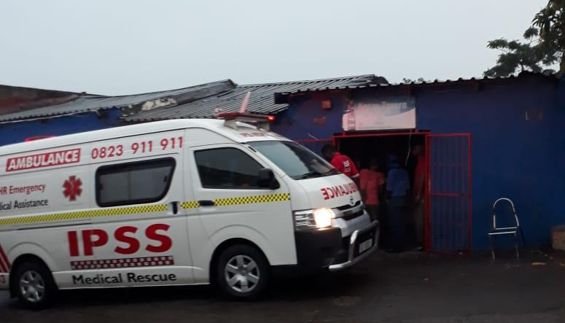
The ambulance outside the building in Ntshaweni were the young girl died after being hit by lightning. Photo: IPSS Medical Rescue

