Lightning kills Voi woman, 66, while digging trench in downpour
https://www.the-star.co.ke/news/2018/03/02/lightning-kills-voi-woman-66-while-digging-trench-in-downpour_c1723951
Mar. 02, 2018, 6:00 pm
By MALEMBA MKONGO @malemba_mkongo
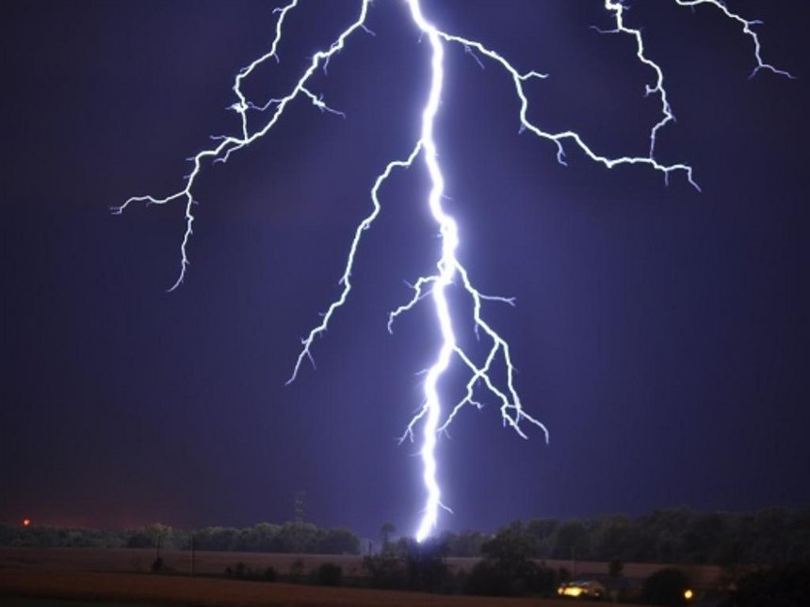
"The 66-year-old was digging a trench near her house during a heavy downpour when she was struck by lightning in Voi, March 2, 2018."
A woman died after she was struck by lightning in her house at Sofia estate in Voi, Taita Taveta county on Friday.
The 66-year-old was digging a trench near her house during a heavy downpour when she was struck.
Area police boss Fredric Ochieng said the woman fell unconscious and was rushed to Moi referral hospital where she later died.
"Her body is lying at the same hospital mortuary awaiting post mortem," Ochieng said.
Separately, two people were killed after their house collapsed following a heavy downpour in Msengoni village, Taveta.
Ochieng said the two were asleep when the mud-walled house crumbled.

