**Lightning strikes, injures 77 pupils in Nebbi - Uganda**  
<https://www.monitor.co.ug/uganda/news/national/lightning-strikes-injures-77-pupils-in-nebbi-4709034>  
  
31 July, 2024

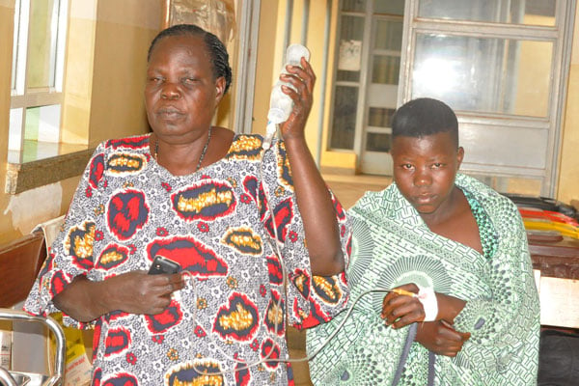

Ms Gabby Yanijo, the woman councilor for Oweko Parish, assists one of the pupils struck by lightning. PHOTO BY PATRICK OKABA

By Patrick Okaba

About 77 primary school pupils were struck by lightning in Oweko primary school, Ndhew Sub-County in Nebbi district on Wednesday afternoon.

 According to an eyewitness, the lightning struck the pupils while they were playing football. The pupils hailed from different primary schools of Owilo, Ogalo, Padel, Omoyo, with Oweko playing host to the primary school games.

One of the residents of Oweko Centre, Mr Peter Okaba, told this publication that he heard a loud bang with sparkling bright light. Shortly, he heard an alarm and children crying.

 “When we went to see what happened, we found pupils had been struck by lightning. We then started connecting for a rescue team for an ambulance from Nebbi hospital which is over four kilometres (away),” he said.

 In the rural areas, most pupils play football with bare feet. And to exacerbate the problem, the area is on a flat. Lightning incidents are common in Erussi and Ndhew Sub-counties during the rainy seasons.

 The school head teacher for Oweko Primary school, Ms Roseline Mungacel, said: “We have 77 pupils, one teacher and one community member who were struck. Seven who were badly injured were rushed to Nebbi hospital for treatment. The incident happened at midday.”

 She said the school does not have a lightning arrestor. “We have not recorded any death cases,” she said.

 She identified the critically injured as Rose Ayiorwoth, a teacher from Owilo Primary School, Gloria Atyeronimungu, Lynette Pimer, Bridget Micparwoth, Saviour Afoyorwoth and Marvin Yikparwoth, all pupils from Omoyo Primary School, who are receiving treatment at Nebbi hospital.

 The LCIII Chairman for Ndhew Sub- County, Mr Bosco Okwai, said the pupils reported from different schools and were for school primary football and netball competitions and Oweko Primary School playground.

 “The pupils sustained injuries and we have not registered death cases. The games had to be stopped as we rushed the injured pupils to Nebbi hospital for treatment,” he said.

 He adds that during the rain showers, all the schools who reported for football and netball competitions pupils took shelter in the host school. He said one of the teachers was also struck.

**Incidences**

In September 2023, lightning struck dead three children and injured one in two separate incidents in West Nile. Fahad Bangutu, 12, a Primary three pupil of Lodonga Black Primary School, and Zaidin Ayub, 9, a Primary one pupil from the same school were struck as they were boiling water in a kitchen at home.

 Similarly, 12-year-old Suraya Ayub sustained injuries and a 16 year-old boy identified as Sabir was struck dead by lightning at Kebir Cell, in Kenya Ward in Central division last year.

**Safety guidelines**

When it is raining, never use a cliff or rocky overhang for shelter. Health experts advise that one must immediately get out of and away from ponds, lakes, and other bodies of water. One must also stay away from objects that conduct electricity such as barbed wire fences, power lines, or windmills.